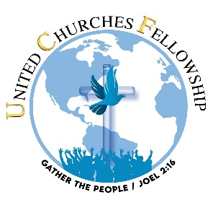 | 27th Annual Holy Convocation  REGISTRATION FORM  Saints Don’t Stop Praying!

Register by July 31st, 2024, and pay $50 per person age 18 and above.; after July 31th $80 per person. There is no registration fee for those age 17 and below.
NAME
ADDRESS
TELEPHONE
EMAIL
CHURCH NAME | Faith ad Love Center Pentecostal Church

Please list the names of all who will attend. Please include the age of anyone age 17 and below.
NAME | ADDRESS  (if different from above) | EMAIL

Send your check or money order made payable to United Churches Fellowship to
8032 Thouron Avenue, Philadelphia, PA 19150
OR
via CashApp $Give2UCF

