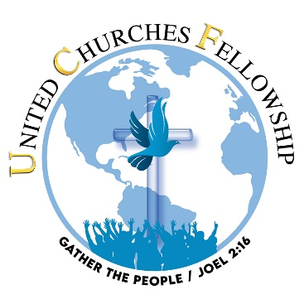
25th Holy Convocation
Registration Form

REGISTRATION FEE: $40/person aged 18 and above

Early Bird Special:
Register by April 30, 2022, pay only $25 per person
Register by August 31, 2022, pay only $35 per person

NAME
NAME
ADDRESS
PHONE |  | EMAIL
CHURCH NAME

Please provide the names and ages of all attendees under the age of 18:

Send your check or money order, made payable to United Churches Fellowship, to 8032 Thouron Avenue, Philadelphia, PA 19150
or
via Cashapp $Give2UCF

Be sure to indicate “CONVOCATION REGISTRATION” in the comments section.

